ALUMNI CONNECT PORTAL

Submitted in partial fulfillment of the requirements of the degree

BACHELOR OF ENGINEERING IN COMPUTER ENGINEERING

By

**Deven Khade A-52**

**Ajit Jadhav A-35**

**Srushti Kunde A-58**

**Pratham Giri A-30**

Supervisor

**Prof. Snehal Chitale**



Department of Computer Engineering

**MES Pillai’s HOCL College of Engineering and Technology**

University of Mumbai (AY 2021-22)

**CERTIFICATE**

This is to certify that the Mini Project entitled “**Alumni Connect Portal**” is a bonafide work of **Deven Khade (52)** submitted to the University of Mumbai in partial fulfillment of the requirement for the award of the degree of “**Bachelor of Engineering**” in “**Computer Engineering**”

Prof. Snehal Chitale

(Supervisor)

Ms.Rohini Bhosale Dr. J.W. Bakal

(Head of Department) (Principal)

**CERTIFICATE**

This is to certify that the Mini Project entitled “**Alumni Connect Portal**” is a bonafide work of **Ajit Jadhav (35)** submitted to the University of Mumbai in partial fulfillment of the requirement for the award of the degree of “**Bachelor of Engineering**” in “**Computer Engineering**”

Prof. Snehal Chitale

(Supervisor)

Ms.Rohini Bhosale Dr. J.W. Bakal

(Head of Department) (Principal)

**CERTIFICATE**

This is to certify that the Mini Project entitled “**Alumni Connect Portal**” is a bonafide work of **Srushti Kunde (58)** submitted to the University of Mumbai in partial fulfillment of the requirement for the award of the degree of “**Bachelor of Engineering**” in “**Computer Engineering**”

Prof. Snehal Chitale

(Supervisor)

Ms.Rohini Bhosale Dr. J.W. Bakal

(Head of Department) (Principal)

**CERTIFICATE**

This is to certify that the Mini Project entitled “**Alumni Connect Portal**” is a bonafide work of **Pratham Giri (30)** submitted to the University of Mumbai in partial fulfillment of the requirement for the award of the degree of “**Bachelor of Engineering**” in “**Computer Engineering**”

(Prof. Snehal Chitale)

Ms.Rohini Bhosale Dr. J.W. Bakal

(Head of Department) (Principal)

**MINI PROJECT APPROVAL**

The Mini Project entitled “Alumni Connect Portal” by **Deven Khade (52)** is approved for the degree of **Bachelor of Engineering** in **Computer Engineering.**

**Examiners**

**1…………..………………………….**

**(Internal Examiner Name & Sign)**

**2…………..………………………….**

**(External Examiner Name & Sign)**

Date:

Place:

**MINI PROJECT APPROVAL**

The Mini Project entitled “Alumni Connect Portal” by **Ajit Jadhav (35)** is approved for the degree of **Bachelor of Engineering** in **Computer Engineering.**

**Examiners**

**1…………..………………………….**

**(Internal Examiner Name & Sign)**

**2…………..………………………….**

**(External Examiner Name & Sign)**

Date:

Place:

**MINI PROJECT APPROVAL**

The Mini Project entitled “Alumni Connect Portal” by **Srushti Kunde (58)** is approved for the degree of **Bachelor of Engineering** in **Computer Engineering.**

**Examiners**

**1…………..………………………….**

**(Internal Examiner Name & Sign)**

**2…………..………………………….**

**(External Examiner Name & Sign)**

Date:

Place:

**MINI PROJECT APPROVAL**

The Mini Project entitled “Alumni Connect Portal” by **Pratham Giri (30)** is approved for the degree of **Bachelor of Engineering** in **Computer Engineering.**

**Examiners**

**1…………..………………………….**

**(Internal Examiner Name & Sign)**

**2…………..………………………….**

**(External Examiner Name & Sign)**

Date:

Place:

**Contents**

|  |  |
| --- | --- |
| Abstract |  |
| 1 Introduction  1.1 Introduction  1.2 Motivation  1.3 Problem Statement & Objectives  1.4 Organization of the Report | 1 |
| 2 Literature Survey  2.1 Survey of Existing System  2.2 Limitation Existing system or research gap | 4 |
| 3 Proposed System ( New Approach of Data Summarization )  3.1 Introduction  3.2 Architecture/ Framework  3.3 Algorithm and Process Design  3.4 Details of Hardware & Software  3.4 Experiment and Results  3.5 Conclusion and Future work. | 5 |
| References | 21 |

**Abstract**

Currently used methods for collecting alumni details is very time consuming as one has to manually update the alumni profile. A web based alumni software would provide with a single repository for entire alumni data. This modification will be updated only with proper validation of the student by administrator. The objective of this Alumni Connect Portal application is to allow old and new students of a university or college to communicate with each other. This allows students to know about each other and their current activities, which is very vital to establish a long-term-relationship. This system would not just be a means to explore academic memories but it will also a system that will provide features such as listing of featured alumni, advanced search notifications, alumni notice boards for various alumni related notifications and photo gallery.

**1. INTRODUCTION**

* 1. **Introduction**

Alumni Connect Portal serves the alumni in carrying out a variety of activities. It strengthens ties between alumni, as well as between alumni and Alma Mater, providing opportunities for cooperation and communication. Interactions with them have always been beneficial to the university as it reduces the industry academic gap. The interaction with the alumni is more informal immature and mostly at departmental level. Various departments have frequent interaction with the alumni. They are invited to share their experiences with the current students helping them to get exposure on industry requirements and trend. They are also invited as experts at seminars for delivering guest lecturers in the areas of their expertise, experts,’ judges for competitions etc. The alumnus is an important stakeholder. They are valuable assets of considered to be in any organization university. The alumni of the college are successful in various fields like teaching, government services, business, corporate company, various company secretaries, IT, etc. the college has encouraged meritorious alumni to work as staff members in the university.

**1.2 MOTIVATION**

Today’s students are tomorrow’s alumni and future university supporters. In recent years a lot of importance is given by institutions in building alumni networks worldwide, understanding the significance of mutual benefits. One of the major challenges faced by Alumni Connects is tracking alumni. Alumni Connect Portal will help in solving the above mentioned problem as it would be the medium through the current students, the alumni outside and the institution can exchange information and stay connected.

**1.3 PROBLEM STATEMENT**

There are not many effective applications for Alumni Connect that’s why many of the university are struggling to organize and collect alumni details for effectively using the alumni information. There are many Alumni Connect portal available many of them do not provide full fledge solution. In those systems Admin is only having the sole authority for manipulating details of alumni. Alumni can’t modify their personal details. The process is very slow and it takes time to find the Alumni data and there is no assurance of the confidentiality of the alumni data. Traditional portals are static just providing information about the university, less engaging and do not involve current students and faculty which would otherwise provide a stronger network for the entire community.

**1.4 OBJECTIVE**

In earlier times the alumni details were maintained in excel, from there on significant changes are seen these days making an effective portal would result in a long –term and more engaging experience with the Alumni. The main objective of this application is to provide a centralized repository of alumni detail. This alumni portal will provide search options based on several keywords such as batch, designation, location. It will provide an effective interface for communication and collaboration between alumni and university. Several features that are found in isolation in many systems are brought in to a single portal. It will help in providing notification, posting option, update the profile detail, alumni can search all the details

**Strong Student Network**

Allow past and present student of college or university to register with Alumni Connect program and their current details

**Build Smart Student Community**

Allow old and new student of college or university to communicate with each other and share their ideas and thoughts by events, blogs etc.

**Strong Job Campus Network**

Students can add openings / internship opportunities in their areas. So others can view and apply for same.

**Manual work to Digital Portal**

Exploring features like broadcast message and events on this portal instead of sending personal mails to alumni s & students. Also can introduce student polls option.

1. **LITERATURE SURVEY**

**2.1. SURVEY OF EXISTING SYSTEM**

It is very tough to find and locate the old students of a particular institution and collect their current details using the university records. Searching a particular batch student is a time taking process. In the conventional process to maintain the alumni database is a very big task because it is difficult to get the details of the alumni manually. Updating student current profile is a tedious task. This does not allow efficient data management and retrieval process. A student willing to get information about others has to approach the university or has to search in social networking site which is often tedious. The information if at all available is not updated and often misleading.

**2.2. LIMITATION OF EXISTING SYSTEM**

* Many institutions, colleges and universities maintain the information manually about present & past students. This does not allow efficient data management and retrieval process.
* A student willing to get information about others has to approach the college and obtain the details.
* Often there is the chance that the information may not be available or mislead.

1. **Proposed System**

**3.1. INTRODUCTON**

The proposed system Alumni Connect portal gives the university and corporate a unified platform for communication and collaboration. This system will provide better networking platforms that will maximize alumni engagement while minimizing the effort and time spent by the university. The alumni, current students, faculty and the administrator will be the authorized users of the system. Alumni can be member of this application if they have signed up and provided necessary information in the alumni profile. Non-members can just view the main page and cannot access alumni profile. This system will provide various features such as plan and register events to organize Information, advanced search options, featured alumni scrolls etc.Even the searching for a particular student will be done very easily using this software compared to the conventional process which is often time consuming. The details of the alumni can be retrieved easily in less time. For security purpose, these detail is made available only to the registered and authenticated users.

**3.2. ARCHITECTURE / FRAMEWORK**

* The application allows students to register and then search the data based on different criteria.
* Also it has the benefit of having a centralized database and up to date information.
* A user can easily obtain information about other registered users.

The System is proposed to have the following modules :

1. **Student Module**

They can view event details and search for specific alumni or information.

1. **Dashboard Module**

Here we can see all users (alumni’s and students) with their company name, location and pass out year , so finding some specific user is easy

1. **Edit Profile**

User can edit their profile photo and information like

1. Personal Details
2. Educational Details
3. Professional Detail
4. Location Details
5. Personal Interest
6. **View Profile**

User can see any alumni profile with their photo and all information

**3.3. ALGORITHM & PROCESS DESIGN**

**3.3.1 Registration :**

Algorithm

1. Enter registration details and click on register
2. If required fields are empty then show error message as “Please enter valid inputs”
3. If correct input then save details in database and create user login

Process Design

True

False

Save to DB & Create login

Registration

Is Valid

Enter Inputs

Fig 3.3.1 Process Design of Registration

**3.3.2. Login :**

Algorithm

1. Enter Login credential and click on Login.
2. If Username and Password are empty them show error message as”Please enter valid credential”
3. If correct credential then redirect to dashboard page.

Process Design

Redirect to Dashboard page

Login

Is Valid

Enter Credential

False

True

Fig 3.3.2 Process Design of Login

**3.4. DETAILS OF HARDWARE & SOFTWARE**

* **Client Side** :All kinds of scripts can run on client side

1. HTML :- for Designing of Website
2. CSS :- for Styling of Website
3. JS :- for web-logic's and client side scripting
4. J query :- for web-logic's and client side scripting

* **Server Side** :The server data control by these runs on server dealing with generation of content of web page

1. C# :-back-end code . modern-object-oriented language , type-safe language
2. ASP.NET :- front-end code . Use to code dynamic pages, web services and application .
3. .NET 4.5 :- its framework (for code compilation build) .for building and running windows application
4. IIS :- Internet Information Server . it is a Microsoft server(local host) . extensible web server software.

* **Back End** : where data stores , it contrast with front-end

MySQL :- for data storage . data stores in tabular form

* **Software** :

1. Visual Studio 2019 :-

Its IDE(Integrated Development Environment)

(Code editor + Build tools and debugger)

1. MySQL Workbench :-

It provides data modeling ,SQL development and comprehensive administration tools for server. configuration user administration,backup and much more

* **Hardware** :

1. Processor:- Intel i3
2. Ram:- minimum 2gb
3. Rom:-minimum 256gb
4. Windows web hosting

**3.4. EXPERIMENTS & RESULTS**

**Registration page**

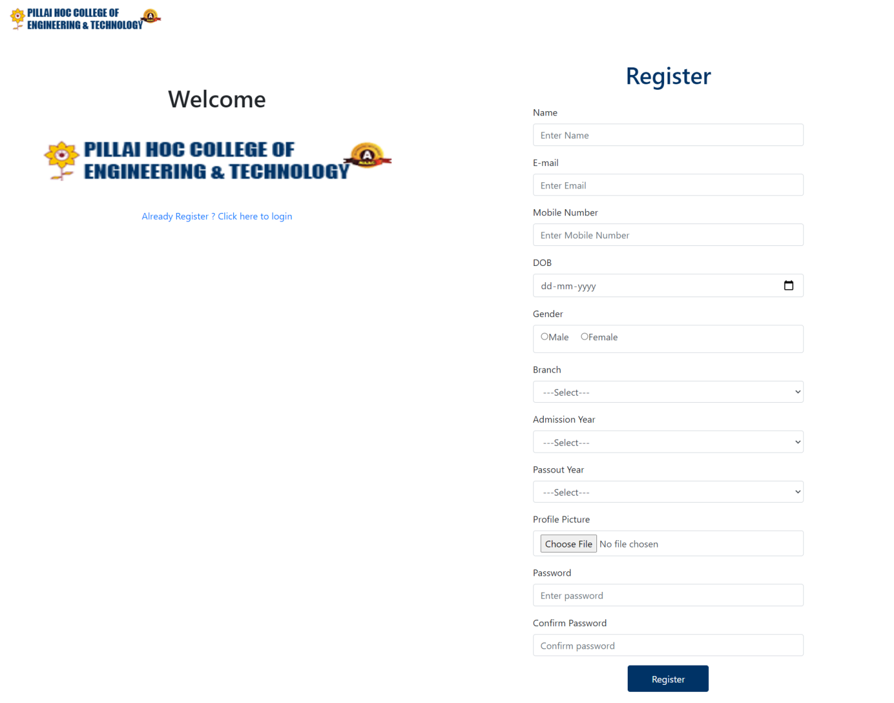

3.4.1 Registration

**Login Page**

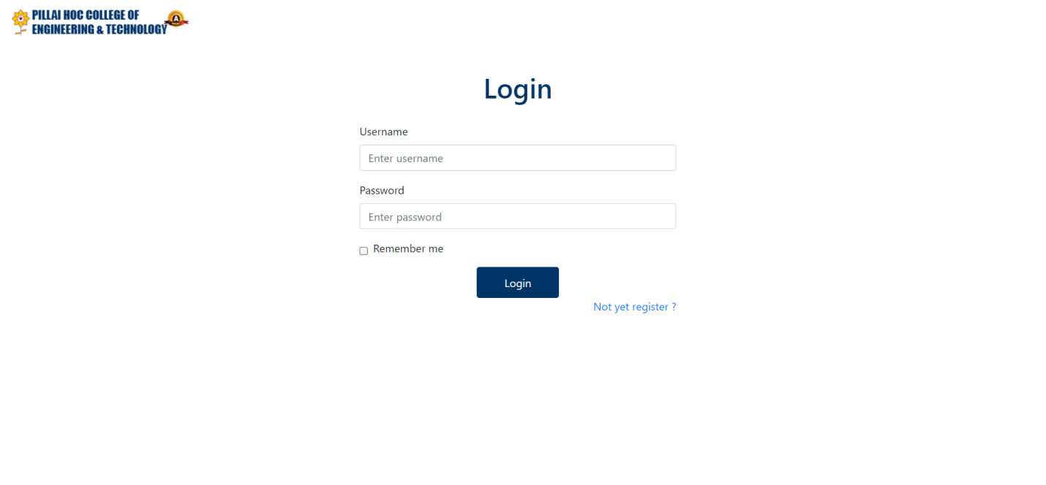

Fig 3.4.2 Login Page

**Dashboard Page**

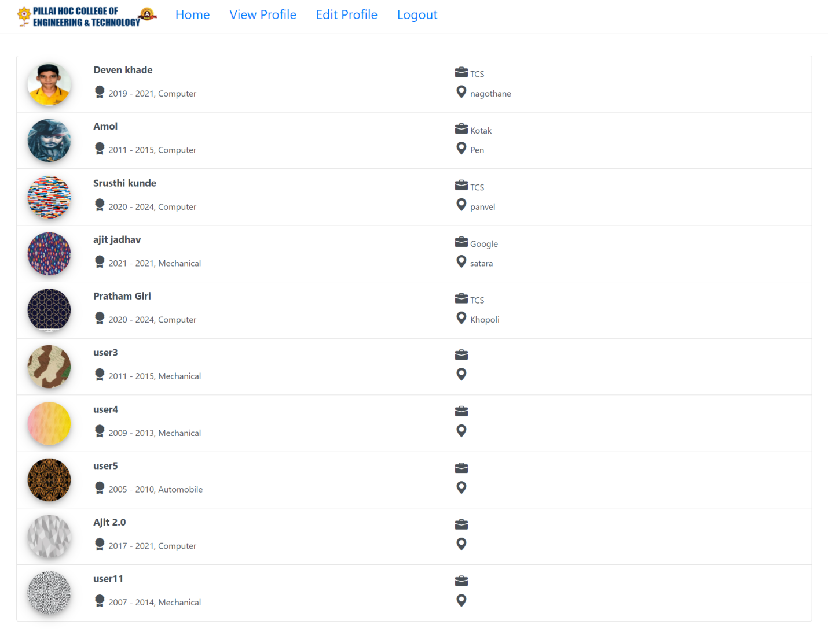

Fig 3.4.3 Dashboard Page

**Edit-Profile Page**

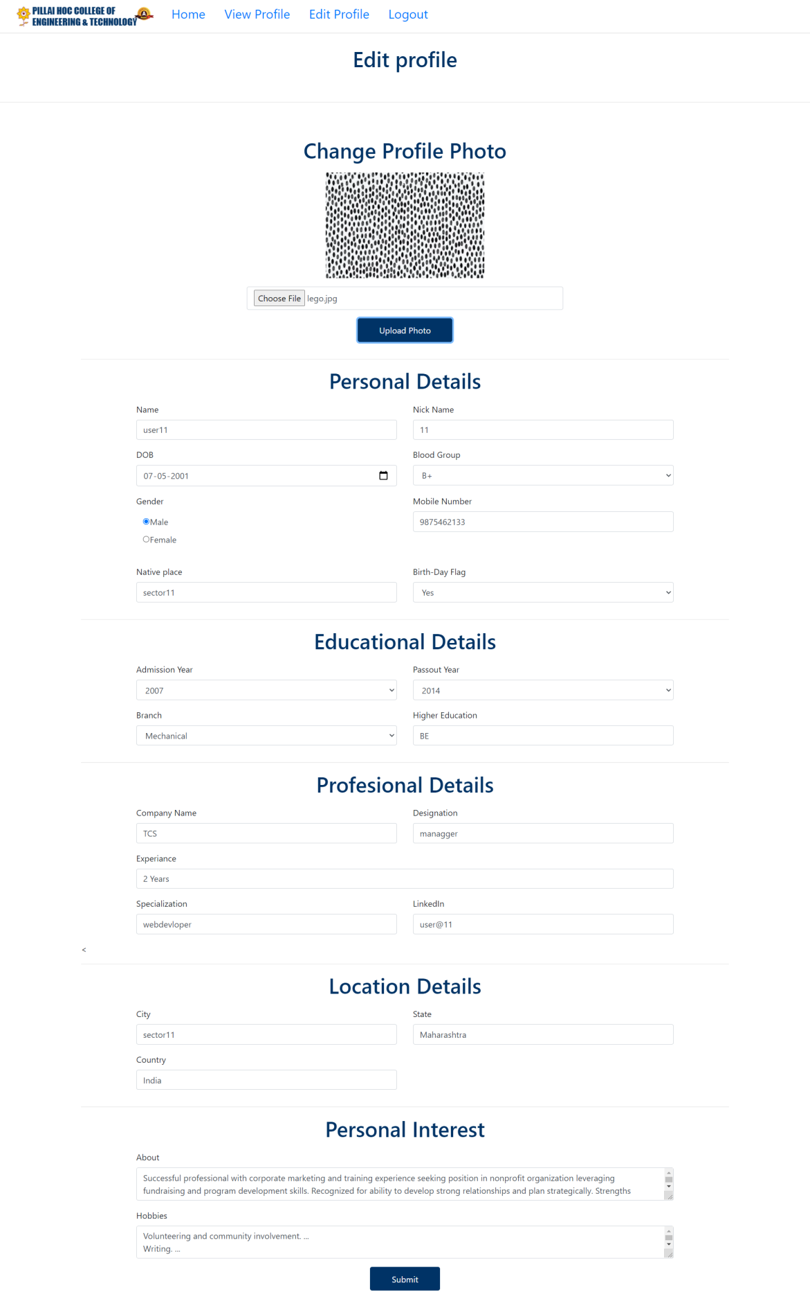

Fig 3.4.4 Edit-Profile Page

**View-Profile Page**

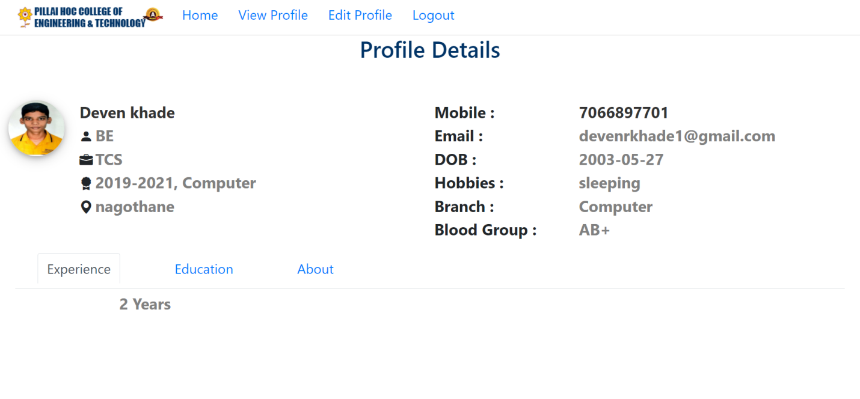

Fig 3.4.5 View Profile Page

**Advantages**

1. **Strong Student Network**

Allowing past and present student of college or university to register with Alumni Connect program and their current details will create updated & genuine data.

Also using Dashboard module, students can connect with each other & college/university to get updates easily.

1. **Build Smart Student Community**

It will help to develop students smart community. So using this, past or present students can share their thoughts, ideas by writing blogs.

Also can arrange events and broadcast on portal that will help to reach all registered students using event module.

1. **Strong Placement Campus Network**

Past & present students can add openings / internship opportunities in their areas. So it will increase placement opportunities.

1. **Manual work to Digital Portal**

Exploring features like broadcast message and events on this portal instead of sending personal mails to alumni s & students or sending on chat groups like whatsapp. Also can introduce student polls option and get digital voting on any topic/ideas.

1. **Centralized Admin Control**

Centralized admin control will provide content security. Registration, Events, Blogs etc. will be appear after admin authorization only.

**3.5 Conclusion and Future work**

Conclusion:-

An Alumni Association is very important for university. This proposed system is a web based application that provides facility for maintaining a central repository of alumni data. Using this web application the alumni can update the profile and alumni can send the job or some other information to communicate through notification to admin.Admin will have authority to verify alumni details, schedule the events, Admin can posting notification, event and some other message will be sending via the batch wise alumni’s. The system is not confined to Alumni but is also extended to current students and faculty for a better engaging experience. This Alumni Association Portal will help the organization in reducing their data collection cost and time. It will increase the number of contact-able alumni.

Future work

* Opening & Internship Module

Alumni can share openings and internship details through portal .for better placement.

* Event Module

It maintains information about various events that conducted

by college and university.

* Broadcast Module

We can Broadcast notifications like Related to college timetables,Exam timetables ,about webinar information and many more.

* Admin Module

Admin is responsible for maintaining information of students

* Authorization Module

It is a sub part of Admin Module .Like if student submits registration form admin will complete verification process and if successful after that only student add details into database

* Birth-Day Module

To show and hide birthday on profile page OR in brodcast module for notification of someone’s birthday.

* Blog Module

It maintains information about various Blogs that conducted

by college and university.

* Live Conference

For making video conference with alumni’s and students.

**Reference :-**

<https://www.researchgate.net/publication/320119228_Design_and_Implementation_of_Student_and_Alumni_Web_Portal>

Websites Reference:

1. <https://dotnet.microsoft.com/en-us/apps/aspnet>
2. <https://www.w3schools.com/>
3. <https://www.c-sharpcorner.com/>
4. <https://dev.mysql.com/>